
Detecting Papaya Fruit Ripeness Level Based on Color Features Using the HSI Color Space Transformation Method

Nia Zanah*, Fadhilah Ramadhani Nst, Muhammad Yudha Pratama

Program Studi Ilmu Komputer, Fakultas Sains dan Teknologi, Universitas Islam Negeri Sumatera Utara, Indonesia

A B S T R A C T
Papaya fruit is one of the kings of fruit in Indonesia. It is said to be the king of fruit because it is rich in benefits and has good nutritional and vitamin content. Grouping the maturity of papaya fruit is very important. The difficulty in clarifying the ripeness of papaya fruit is based on its color features, and the grouping of papaya fruit ripeness is divided into several categories, namely ripe, semi-ripe and unripe. This research aims to predict the level of ripeness of papaya fruit using the K-Nearest Neighbor method using features obtained from extraction results with RGb and HSI images. The system that has been created can classify papaya fruit images into raw, semi-ripe and ripe classes. Programming includes identifying needs, analyzing problems, selecting algorithms, and determining the data structure to be used. The aim of program design is to create a good and effective design before starting to implement the program. The first stage is to design the program using the GUI tool from the Matlab application. In the second stage, the source code must be entered so that the program can be run. Papaya fruit samples that were tested for ripeness were obtained from taking images using several smartphone cameras and at different times. Some were taken during the day, some at night. Table 4. Shows that all of the images of papaya fruit samples are in accordance with the application of papaya ripeness levels. With test results showing that test accuracy reaches a perfect level of 100%. This indicates that the testing system used is able to accurately detect the ripeness of papaya fruit. The use of the K-Nearst Neighbor (K-NN) method has been successfully carried out in this research.

Keywords:
color features, HSI color space transformation, maturity level.
* Correspondence :
Nia Zanah,
Universitas Islam Negeri Sumatera Utara
Email: niazanah25@gmail.com

INTRODUCTION

Papaya fruit is one of the kings of fruit in Indonesia. It is said to be the king of fruit because it is rich in benefits and has good nutritional and vitamin content [1]. The highest nutritional content in papaya fruit is vitamin A [2]. Papaya is a fruit that has good nutritional value, and can be used in the form of fresh fruit and processed products [3]. A digital image is a two-dimensional array or a matrix whose elements represent the gray level of image elements [4]. In order to be processed by a digital computer, an image must be presented numerically with discrete values ​​[5]. Digital images are divided into several types, namely color images, gray scale images and binary images [6]. The use of papaya fruit has long been known by the Indonesian people, the fruit can be consumed fresh and in processed form (a mixture of sauces, sweets and pickles) [7]. Papaya is classified as a fruit with climacteric respiration [8].
With the development of technology, computers have been able to detect the ripeness of papaya fruit from the color characteristics of the fruit's skin. Digital image processing is part of technological developments that require machines (computers) to be able to recognize images like human vision [9]. Image processing is a method or technique that can be used to process images by manipulating them into the desired image data to obtain certain information [10]. In order to be processed by a digital computer, an image must be presented numerically with discrete values. The representation of continuous functions into discrete values ​​is called image digitization [11]. A color space is a specification of a spatial shape (plane, cone, cube, etc.) with coordinates and each color represented by a point within it. Color spaces aim to standardize color specifications [12].
Several processing processes on the images being tested will carry out an image extraction process using HSI images and then carrying out calculations using the K-Nearest Neighbor method [13]. The HSI model has the ability to separate the intensity of intrinsic color information [14]. The HSI color space is used to minimize the impact of uneven lighting on V images [15]. Application of the HSI color space transformation method used to detect fruit skin color [5]. The K-Nearst Neighbor (KNN) algorithm is a classification technique for objects based on the value (K) of their nearest neighbors [16][17][18][19]. Modeling of the H system in obtaining information by combining several color intensities obtained from the RGB image improvement compression process [20].
Based on the problems above, researchers aim to predict the level of ripeness of papaya fruit using the K-Nearest Neighbor method using features obtained from extraction results with RGb and HIS images [21]. In determining the level of fruit ripeness, color and texture are very important indicators [22]. Color pattern recognition is defined as retrieving raw data so that the system can act on previous data.
Inter-class image classification plays an important role in engineering and other computer vision applications [23]. The higher the image resolution, the higher the level of detail of the image [24]. Researchers have categorized papaya into three categories, namely immature, semi-ripe and ripe. papaya fruit knowing the level of maturity of the papaya fruit so that it can determine the level of maturity of the papaya fruit effectively [25].
The advantage of this research compared to previous research is that it can produce extraction values ​​that can be detected using the K-NN algorithm in the HSI color space transformation, so that more accurate classification results can be obtained. This research can help the public in choosing ripe papaya fruit.

METHODOLOGY

This research was conducted to detect the level of ripeness of papaya fruit using HSI images with the K-Nearest Neighbor (KNN) method. At this research stage, the features used are the color features R, G, B, which will then go through an extraction process to become an HSI image and be classified using the KNearest Neighbor (KNN) method. The research stages carried out in this study can be seen in Figure 1 below.

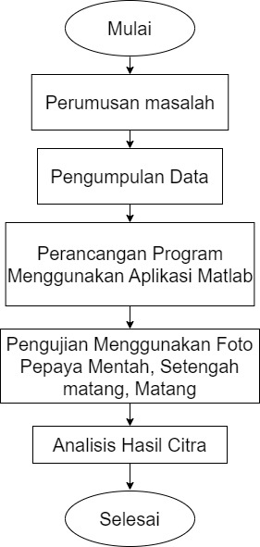
Figure 1. Research Phase Water Diagram

- Formulation of the problem
Problem formulation usually produces ideas or solutions to the problem. Papaya fruit maturity is a dependent variable that wants to be identified from its color characteristics. Ripeness can be divided into categories, such as ripe, medium ripe and unripe.

- Data collection
Data collection is the collection of relevant information, facts, or values ​​from various sources for research purposes. Good and structured data collection is the key to valid and reliable research results. Data collection was carried out by taking papaya fruit samples which were then tested with a fruit maturity recognition model using HSI color space transformation.

- Program Design
Program design is the design and preparation of the steps necessary to develop a computer program. Programming includes identifying needs, analyzing problems, selecting algorithms, and determining the data structures to be used. The aim of program design is to create a good and effective design before starting to implement the program. The first stage is to design the program using the GUI tool from the Matlab application. In the second stage, the source code must be entered so that the program can run.

- Testing Using Photos of Papaya Fruit
Testing using fruit photos refers to the process of using images or photos of fruit as test data to test and validate fruit ripeness detection models or algorithms. An illustration of the test is in Figure 2. Based on Figure 2, the test was carried out using a sample photo of papaya fruit, then the photo of papaya fruit was called first then went through the RGB value calculation process, then went through the RGB to HSI transformation process, and produced the calculated image.

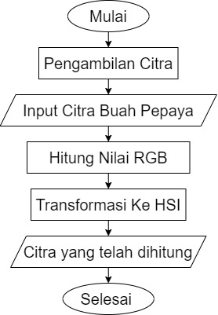
Figure 2. Water Diagram of Testing Stages

- Image Results Analysis
There are three stages of analysis carried out, namely RGB value analysis, RGB to HSI transformation analysis and analysis of the calculated image results. RGB analysis is determining which fruit is unripe, half-ripe, and ripe. Then it is transformed into HIS which is the stage where the testing process is carried out on each image.

RESULTS AND DISCUSSION

At the analysis stage, testing was carried out based on the results of detecting the color of the papaya fruit. Photos of papaya fruit obtained came from gardens, markets and minimarkets. The number of samples used for the analysis process was 9 images with the extension *jpg. Can be seen in Figure 3. is the sample that has been collected.

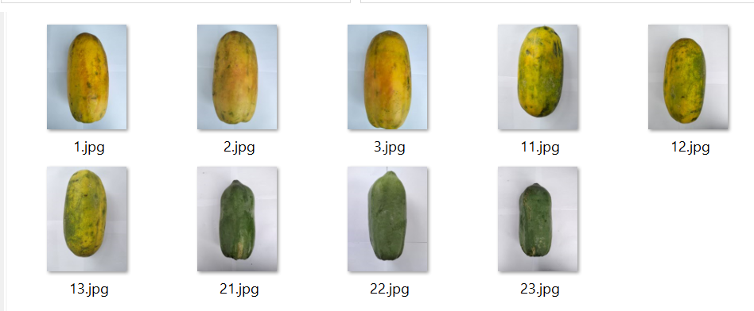
Figure 3. Papaya fruit sample

The results of the program that has been created and run can be seen in Figure 4. This stage is the process of implementing the system that has been built and then testing is carried out to obtain the value for each image tested.

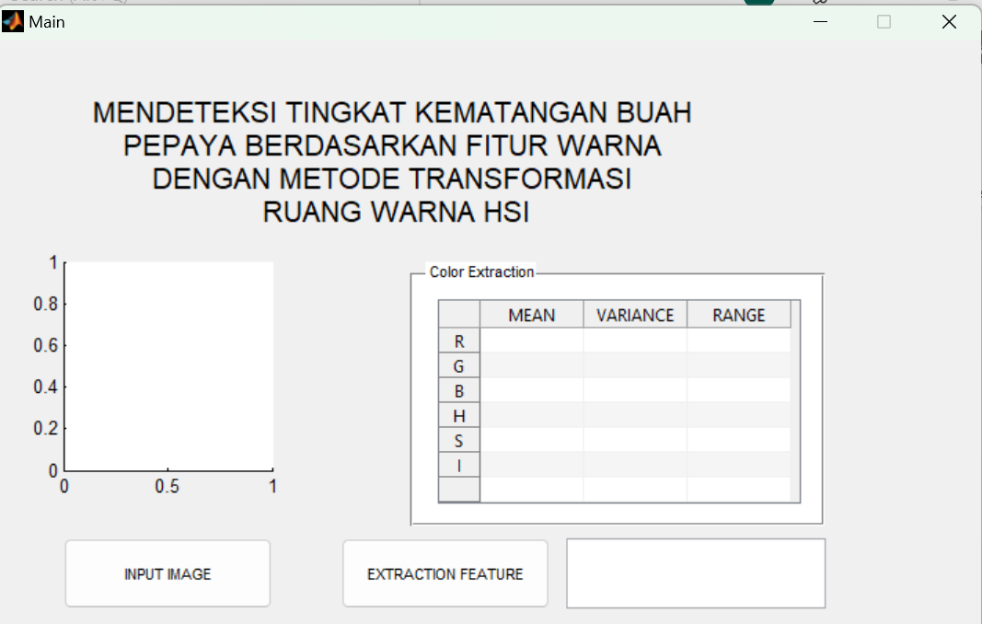
Figure 4. Program Run Results

The results of testing photo samples of papaya fruit contained 9 results according to the number of samples available. One of the results can be seen in Figure 5. The image of the papaya fruit in *jpg format is input image then feature extraction then the system will calculate the RGB by transforming the RGB color system to the HSI color system.

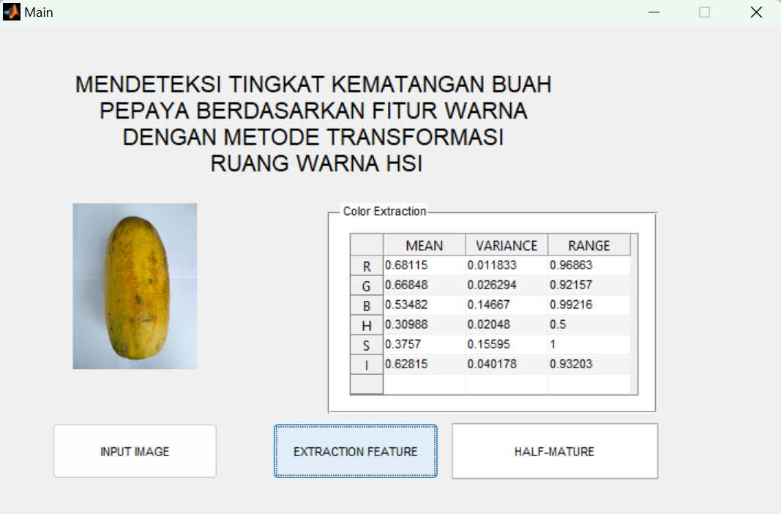
Figure 5. Sample Run Results

The processed samples will be processed using the HSI color transformation method. Where samples were taken of 3 ripe papayas, 3 half-ripe papayas and 3 unripe papayas as range data to determine the classification of fruit ripeness. The image of the papaya fruit in *jpg format was calculated using RGB transformation from the RGB color system to the HSI color system. Can be seen in Table 1 and Table 2.

Table 1. Range of RGB Values
Test  Picture | Range |  |  | Uji | Range |  |  | Test  Picture | Range
Test  Picture | R | G | B | Gambar | R | G | B |  | R | G | B
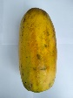 | 0.96863 | 0.92157 | 0.93203 | 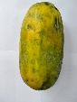 | 0.93333 | 0.90196 | 0.95686 | 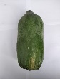 | 0.9451 | 0.94118 | 0.96471
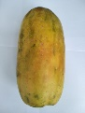 | 0.85098 | 0.91373 | 0.98039 | 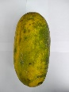 | 0.88627 | 0.9098 | 0.97255 | 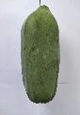 | 0.86667 | 0.85098 | 0.95686
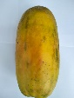 | 0.85098 | 0.92549 | 1 | 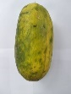 | 0.95686 | 1 | 0.89935 | 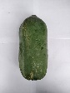 | 0.96863 | 0.92157 | 0.98431

Table 2. Range of RGB to HSI Transformation Values
Test  Picture | Range |  |  | Uji | Range |  |  | Test  Picture | Range
Test  Picture | H | S | I | Gambar | H | S | I | Test  Picture | H | S | I
 | 0.5 | 1 | 0.93203 |  | 0.5 | 1 | 0.9098 |  | 0.46974 | 1 | 0.95033
 | 0.5 | 1 | 0.88105 |  | 0.5 | 1 | 0.92288 |  | 0.5 | 0.6087 | 0.89815
 | 0.5 | 1 | 0.89673 |  | 0.5 | 1 | 0.89935 |  | 00.46974 | 1 | 0.95817

After processing the image, we then checked the classification of the papaya fruit image according to the papaya maturity phase. Calculation of the minimum value, maximum H, minimum value, maximum S and minimum value, maximum I, is able to detect the color of papaya fruit by matching the data range of papaya color values ​​which is the reference in papaya color classification. Seen in Table 3.

Table 3. Range of Papaya Fruit Maturity Categories
Range |  |  | Range |  |  | Range |  |  | Category
 | Min | Max |  | Min | Max |  | Min | Max | Category
H | 0.5 | 0.5 | S | 1 | 1 | I | 0.88105 | 0.93203 | Ripe
H | 0.5 | 0.5 | S | 1 | 1 | I | 0.89935 | 0.92288 | Half-baked
H | 00.46974 | 0.5 | S | 0.6087 | 0.5 | I | 0.89815 | 0.98431 | Raw

Table 4. Calculated Papaya Fruit Detection Results
No | The calculation results |  |  |  | Maturity | Description
No | Sample | H | S | I | Aplikasi
1 |  | 0.5 | 1 | 0.93203 | Ripe | In accordance
2 |  | 0.5 | 1 | 0.9098 | Half-baked | In accordance
3 |  | 0.46974 | 1 | 0.89815 | Raw | In accordance
4 | 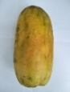 | 0.5 | 1 | 0.88105 | Ripe | In accordance
5 |  | 0.5 | 1 | 0.92288 | Half-baked | In accordance
6 |  | 0.5 | 0.6087 | 0.89815 | Raw | In accordance
7 |  | 0.5 | 1 | 0.89673 | Ripe | In accordance
8 |  | 0.5 | 1 | 0.89935 | Half-baked | In accordance
9 |  | 00.46974 | 1 | 0.95817 | Raw | In accordance

Papaya fruit samples that were tested for ripeness were obtained from taking images using several smartphone cameras and at different times. Some were taken during the day, some at night. Table 4. Shows that all of the images of papaya fruit samples are in accordance with the application of papaya ripeness levels. With test results showing that test accuracy reaches a perfect level of 100%. This indicates that the testing system used is able to accurately detect the ripeness of papaya fruit. The use of the K-Nearst Neighbor (K-NN) method has been successfully carried out in this research.
In previous research, this method was tested with 9 images and the results achieved were 89% [26]. In this research, it was further developed using 30 image samples and achieved 100% accuracy.

CONCLUSION

Based on the results of the application experiment, the system that has been created can classify images of papaya fruit into raw, semi-ripe and ripe classes. The papaya fruit maturity level classification system with 9 papaya fruit data divided into 3 with raw, 3 semi-ripe, and 3 ripe ripeness levels can be implemented well. Applications built using the HSI color model with the HIS color space transformation method obtained 100% accuracy.

REFERENCES

[1] K. B. D. R. Nur Widyasari, U. D. Rosiani, and A. N. Pramudhita, "Implementation of a Papaya Fruit Ripeness Level Detection System Using the RGB Method," Smatika J., vol. 11, no. 01, pp. 32–36, 2021, doi: 10.32664/smatica.v11i01.536.
[2] Alfian Firlansyah, Andi Baso Kaswar, and Andi Akram Nur Risal, "Classification of Papaya Fruit Ripeness Levels Based on Color Features Using ANN," Techno Xplore J. Computer Science. and Technol. Inf., vol. 6, no. 2, pp. 55– 60, 2021, doi: 10.36805/technoxplore.v6i2.1438.
[3] K. Suketi, R. Poerwanto, and S. Sujiprihati, "Physical and Chemical Characteristics of Papaya Fruit at Different Maturity Stages Physical and Chemical Characteristics of Papaya at Different Maturity Stages," Agronomy, vol. 38, no. 1, pp. 60–66, 2020.
[4] Ellif, S. H. Sitorus, and R. Hidayati, “Naïve Bayes 1.,” Coding J. Komput. and Appl., vol. 09, no. 01, pp. 66–75, 2021.
[5] Y. F. Br Tarigan, K. Andriani, R. Rosnelly, and W. Wanayumini, "Implementation of the HSI Method in Color Space Transformation in Detecting the Ripeness of Shrimp Mango Fruit," J. Media Inform. Budidharma, vol. 6, no. 4, p. 2257, 2022, doi: 10.30865/mib.v6i4.4547.
[6] Doni, "Implementation of Image Quality Improvement Using the Lucy-Richardson Method," Maj. Ilm. CORE, vol. 14, no. September, pp. 275–278, 2019.
[7] E. Syaefulloh and H. Purwadaria, "IDENTIFICATION OF MATURITY AND MATURITY LEVELS OF IPB 1 PAPAYA (Carica papaya L.) USING DIGITAL IMAGE PROCESSING AND ARTIFICIAL NEURAL NETWORKS," Agritech J. Fak. Technol. Pertan. UGM, vol. 27, no. 2, pp. 75–81, 2007.
[8] M. L. Taris, W. D. Widodo, and K. Suketi, "Maturity Criteria for IPB Callina Papaya Fruit (Carica papaya L.) from Several Harvest Ages," J. Hortik. Indonesia., vol. 6, no. 3, p. 172, 2015, doi: 10.29244/jhi.6.3.172-176.
[9] S. P. Adenugraha, V. Arinal, and D. I. Mulyana, "Classification of Ambon Banana Ripeness Using KNN and PCA Methods Based on RGB and HSV Images," J. Media Inform. Budidharma, vol. 6, no. 1, p. 9, 2022, doi: 10.30865/mib.v6i1.3287.
[10] T. Banana Fruit Ripeness Based on Banana Skin Image Color Features Sakir et al., "Application of the HSI Color Space Transformation Method for Detection," vol. XIV, no. 3, pp. 243–254, 2020.
[11] O. N. Shpakov and G. V. Bogomolov, “Technogenic activity of man and local sources of environmental pollution,” Stud. Environ. Sci., vol. 17, no. C, pp. 329–332, 1981, doi: 10.1016/S0166-1116(08)71924-1.
[12] S. Computer, D. Selatan, K. Denpasar, and D. Kesegaran, "Detection of Freshness of Apples, Bananas, and Oranges Using the HSI Color Space Transformation Method and K-Nearest Neighbor," vol. 8, no. 1, pp. 1–10, 2024.
[13] W. P. Atmaja and V. Lusiana, "CLASSIFICATION OF PEKALONGAN BATIK TYPES USING HSI IMAGE WITH THE K-NEAREST NEIGHBOR METHOD," vol. 8, no. April, pp. 1–8, 2023.
[14] D. Wandi, F. Fauziah, and N. Hayati, "Detection of Wiltiness in Roses Using HSI and HSV Color Space Transformation Methods," STRING (Ris. and Inov. Teknol Writing Unit., vol. 5, no. 3, p. 333, 2021, doi: 10.30998/string.v5i3.8464.
[15] R. Azhar, A. Z. Arifin, and W. N. Khotimah, "Integration of Density-Based Clustering and HMRF-EM in HSI Color Space for Tuna Fish Image Segmentation," Inspir. J. Technol. Inf. and Commun., vol. 6, no. 1, pp. 28–37, 2016, [Online]. Available: https://jurnal.akba.ac.id/index.php/inspiration/article/view/89
[16] D. I. Muhammad, E. Ermatita, and N. Falih, "Using K-Nearest Neighbor (KNN) to Classify Starfruit Images Based on Color Features," Inform. J. Computer Science., vol. 17, no. 1, p. 9, 2021, doi: 10.52958/iftk.v17i1.2132.
[17] S. R. Raysyah, Veri Arinal, and Dadang Iskandar Mulyana, "Classification of Coffee Fruit Maturity Levels Based on Color Detection Using Knn and Pca Methods," JSiI (Journal of Information Systems), vol. 8, no. 2, pp. 88–95, 2021, doi: 10.30656/jsii.v8i2.3638.
[18] F. Liantoni, "Leaf Classification with Improved Image Features Using the K-Nearest Neighbor Method," J. Ultim., vol. 7, no. 2, pp. 98–104, 2016, doi: 10.31937/ti.v7i2.356.
[19] M. M. Baharuddin, H. Azis, and T. Hasanuddin, "Performance Analysis of the K-Nearest Neighbor Method for Identifying Glass Types," Ilk. J. Ilm., vol. 11, no. 3, pp. 269–274, 2019, doi: 10.33096/ilkom.v11i3.489.269-274.
[20] B. Yanto, J. Jufri, A. Lubis, B. H. Hayadi, and E. Armita, NST, "Clarification of Pineapple Ripeness Using Hue Saturation Intensity (Hsi) Color Space," INOVTEK Polbeng - Seri Inform., vol. 6, no. 1, p. 135, 2021, doi: 10.35314/isi.v6i1.1882.
[21] A. I. Thoriq, M. H. Zuhri, P. Purwanto, P. Pujiono, and H. A. Santoso, "Classification of Banana Maturity Levels Based on Skin Image with HSI Color Space Transformation Features Using the K-NN Method," J. Dev. Res., vol. 6, no. 1, pp. 11–15, 2022, doi: 10.28926/jdr.v6i1.200.
[22] O. R. Indriani, E. J. Kusuma, C. A. Sari, E. H. Rachmawanto, and D. R. I. M. Setiadi, "Tomatoes classification using K-NN based on GLCM and HSV color space," Proc. - 2017 Int. Conf. Innov. Creat. Inf. Technol. Comput. Intel. IoT, ICITech 2017, vol. 2018-January, pp. 1–6, 2018, doi: 10.1109/INNOCIT.2017.8319133.
[23] I. F. Astuti, F. D. Nuryanto, P. P. Widagdo, and D. Cahyadi, "Oil palm fruit ripeness detection using K-Nearest neighbor," J. Phys. Conf. Ser., vol. 1277, no. 1, 2019, doi: 10.1088/1742-6596/1277/1/012028.
[24] H. Edha, S. H. Sitorus, and U. Ristian, "APPLICATION OF THE HUE SATURATION INTENSITY (HSI) COLOR SPACE TRANSFORMATION METHOD FOR DETECTING THE RIPENESS OF HENDRYANTO'S SWEET HARUM MANGO FRUIT," J. Komput. and Appl., vol. 8, no. 1, pp. 1–10, 2020.
[25] I. B. Suban, A. Paramartha, M. Fortwonatus, and A. J. Santoso, "Identification of the Maturity Level of Carica Papaya Using the K-Nearest Neighbor," J. Phys. Conf. Ser., vol. 1577, no. 1, 2020, doi: 10.1088/1742-6596/1577/1/012028.

